# SPRINT 2

**TEAM ID: PNT2022TMID53558**

# REAL TIME RIVER WATER QUALITY MONITORING AND CONTROL SYSTEM

**AIM:**

To create device in the IOT Watson Platform and Configure Node Red Services.

# REQUIREMENT:

IBM cloud, IBM IOT WATSON PLATFORM,NODE RED SERVICES.

# WORKFLOW:

**STEP 1:**

Log on to IBM cloud and create IBM Watson IOT Platform from IBM cloud Dashboard.

# STEP 2:

After Creating IBM Watson IOT Platform,create an Organization (ex.84708c ID: 84708c Bluemix Free)

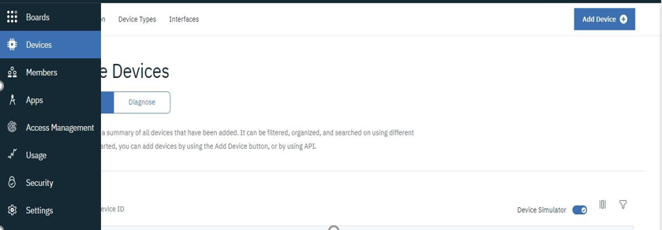

# STEP 3:

Create an device IBM IOT PALTFORM.

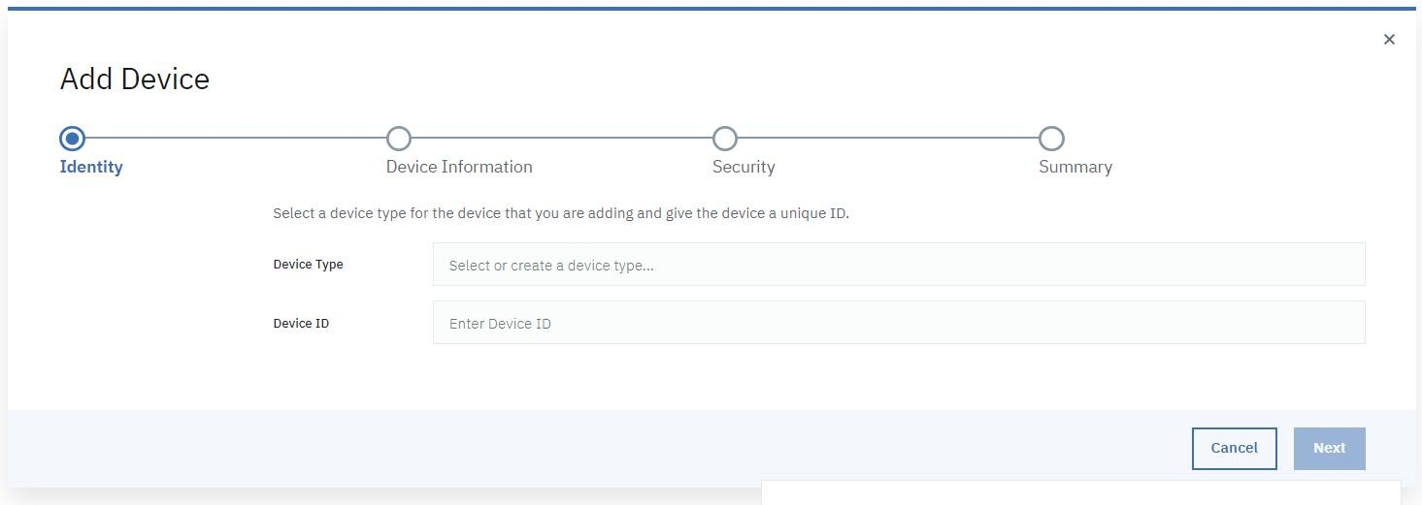

TYPE THE REQUIRED FIELDS (TYPE: ESP32 , ID: 1234) GIVE AUTH-TOKEN.

# STEP 4:

NODE RED SERVICE

* INSTALL IBM IOT IN MANGE PALETTE.
* INSTALL NODE RED DASHBOARD.

# STEP 5:

**Configuring the corresponding nodes**

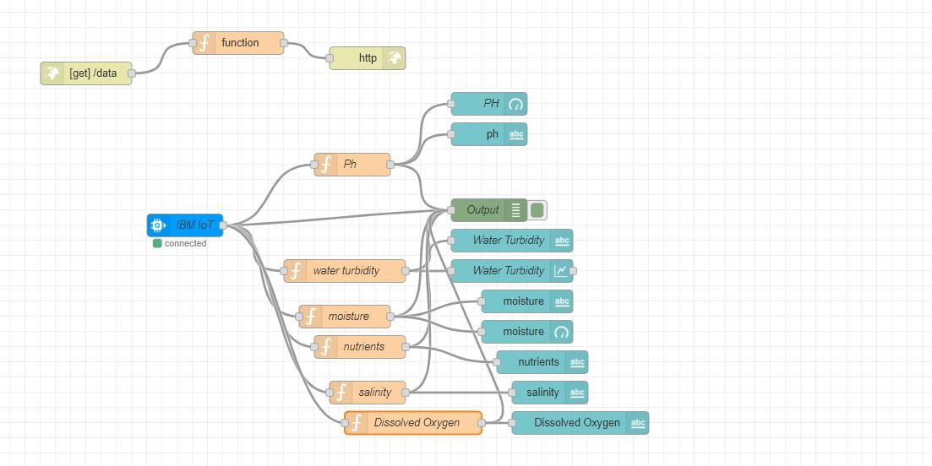

# STEP 6:

Deploy the Services and verify the output values.

# OUTPUT IN IBM WATSON IOT PLATFORM:

